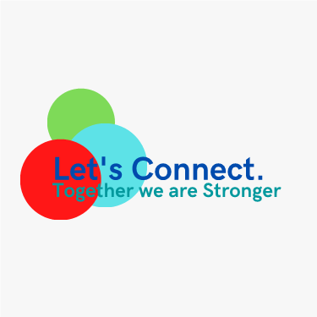
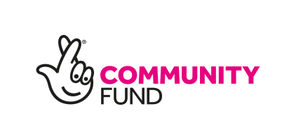
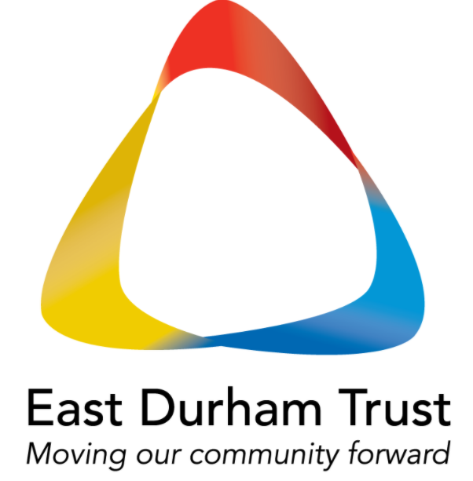
Let’s Connect
The world has certainly thrown up many challenges for us all recently. The ‘Let’s Connect’ project offers a range of opportunities for people to come together to receive and provide support.

Our warm and friendly team offer 1:1 support, peer support groups, peer support training, facilitate the creation of mutual aid groups and provide training to organisations.

Are you 16+ need support or are interested in any of the following?
  - Support for depression and anxiety
  - Increasing your wellbeing
  - Getting out and meeting others
  - Taking part in positive activities
  - Providing peer support
  - Being a part of a mutual aid group
  - Training for your organisation:
Dealing with distress, safety planning and building resilience

Contact the Let’s Connect team on 0191 5185070
or email LCED@hartlepoolmind.co.uk

